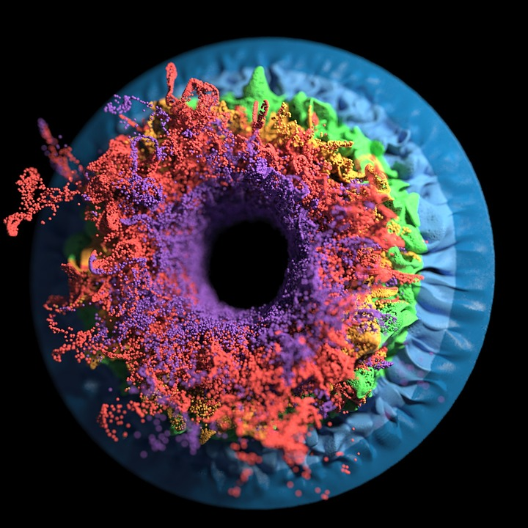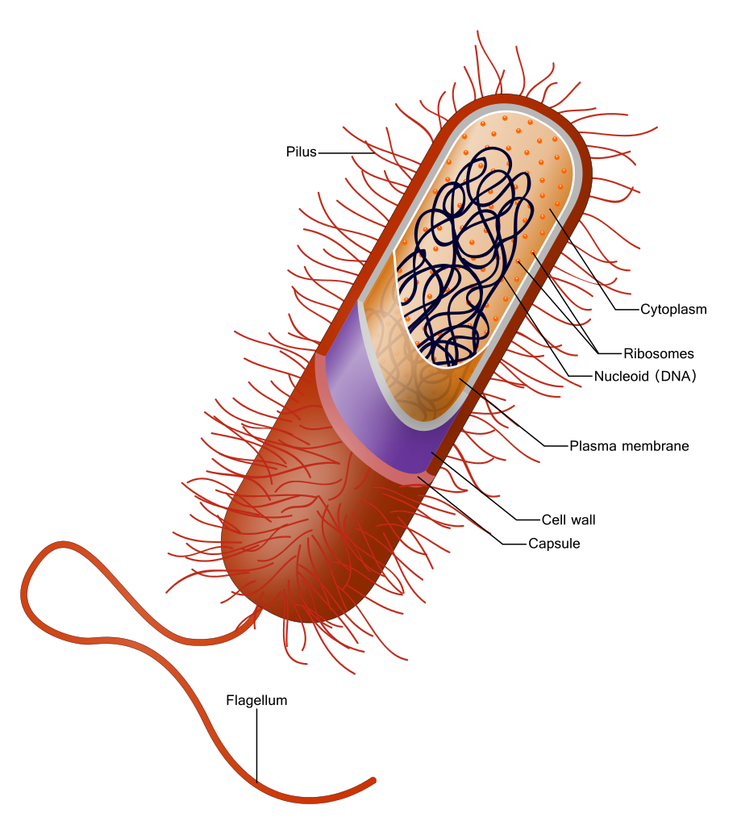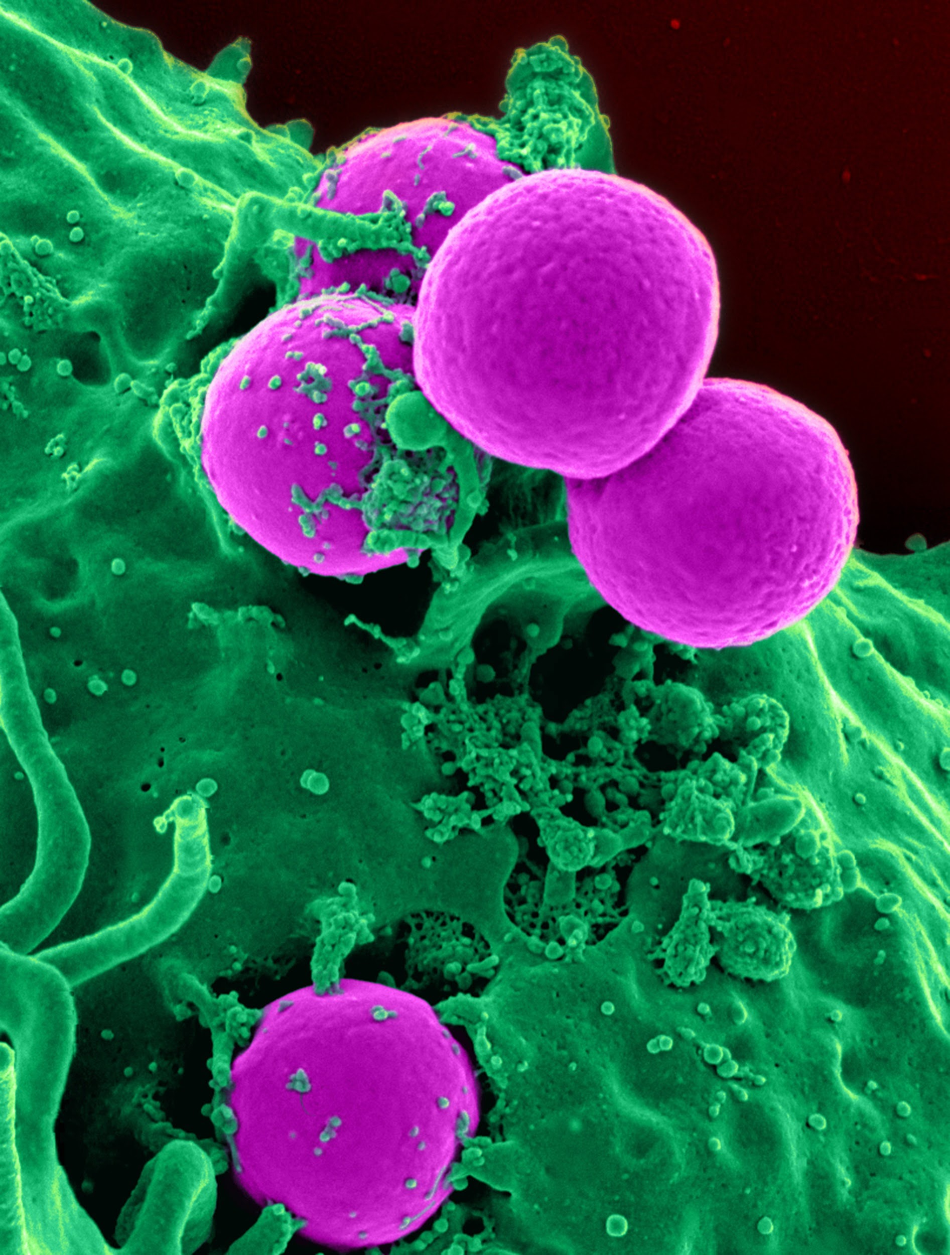
Medical Microbiology
Mr. Roy Garcia, II
Email: rcgarcia@sharylandisd.org
Telephone: 956-271-1600, Ext. 4154
Rm 218 - 4th Blk Conference: 5th Block
REMIND: @8876dg
Tutoring (Rm 218): Monday
and Wednesday Mornings @ 7:30 AM
(Please, let me know the day before if coming in)

Course Description
Students in medical microbiology explore the microbial world, studying topics such as pathogenic and non-pathogenic microorganisms, laboratory procedures, identifying microorganisms, drug resistant organisms, and emerging diseases. While microbiology is the study of all microscopic life, medical microbiology is most concerned with those creatures which have a particular impact on medicine and their clinical implications. This course is beneficial for those wishing to pursue a medical career (especially in a laboratory setting). More than other introductory biological sciences, the study of medical microbiology requires even the beginning student to learn and put into practice a series of unique techniques and concepts. The necessity to maintain a consistent work ethic, perform and evaluate laboratory experiments, read and evaluate technical information, and memorize are required for success in this course.

Big Ideas
1. Understand the immune system’s response to invading microorganisms.
2. Working knowledge of basic bacterial laboratory techniques
3. Foundations of Microbiology - classification, evolution, and growth of microorganisms
4. Microbial Ecology - medical and practical uses for microorganisms
5. Infectious Diseases – What happened when your body is not in homeostasis?!

COURSE CONTENT/TOPIC HEADINGS:
Chpt 1 - Main Themes of Biology Chpt. 15 - Adaptive, Specific Immunity & Immunization
Chpt. 2 - The Chemistry of Biology Chpt. 16 - Disorders in Immunity
Chpt. 3 - Tools of The Lab: Studying Microbes Chpt. 17 - Diagnosing Infections
Chpt. 4 - Prokaryotic Cells & Microorganisms Chpt. 18 - The Cocci of Medical Importance
Chpt. 5 - Eukaryotic Cells & Microorganisms Chpt. 19 - Gram-Positive Bacilli of Medical Importance
Chpt. 6 - Introduction of Viruses Chpt. 20 - Gram-Negative Bacilli of Medical Importance
Chpt. 7 - Microbial Nutrition, Ecology, & Growth Chpt. 21 - Misc. Bacterial Agents of Disease
Chpt. 8 - Microbial Metabolism Chpt. 22 - Fungi of Medical Importance
Chpt. 9 - Microbial Genetics Chpt. 23 - Parasites of Medical Importance
Chpt. 10 - Genetic Engineering Chpt. 24 - Viruses That Infect Humans: The DNA Viruses
Chpt. 11 - Physical & Chemical Agents Chpt. 25 - RNA Viruses That Infect Humans
Chpt. 12 - Drugs, Microbes, Host Chpt. 26 - Environmental Microbiology
Chpt. 13 - Microbe-Human Interactions Chpt. 27 - Applied & Industrial Microbiology
Chpt. 14 - Host Defenses

Grading:
The weight distribution of the following will be used to determine the overall final grades.
Major assignments:60% → Tests, Projects, Lab Reports, Presentations, Notebook.
Minor assignments: 20% → Daily work, Quizzes, Homework, Lab Work, Binder Checks

The semester exams will be worth 20% of your six weeks grade.

- All work handed in must be neat with clear legible handwriting if it is not legible it will not be graded.
- The student must also put their name, date and block on all work handed in. *assignments without this will not be graded if it is lacking this.
- Any work requiring problem solving must show all the work or no credit will be given.
*a minimum of a 50 will be given assuming all answers are correct w/ correct units.

Late work and Make-up work:
Students with and EXCUSED ABSENCE from school will have the opportunity to make up missed work at the rate of one day for one day missed, with a maximum of five days. Students will receive a zero for any major or minor assignments not made up within the allotted time.
Students with an UNEXCUSED ABSENCE may not make up missed work; however, if the unexcused absence is determined to be caused by an extenuating circumstance, makeup work may be allowed. The grade for the makeup work will be no higher than a 70.

Re-Testing
Students will be given the opportunity to re-test on a major grade in the event that they are absent and or have a failing test grade. Absent students will be allowed three days to inform me when they can come in to re-test. According to district policy, making up an exam because of an excused absence will be allowed the full grade to be awarded.
In the event that a student fails an exam, they will have three days to come in for tutoring and set up an appointment to re-test. According to district policy, making up an exam because of a failing grade will automatically lose 30 pts. So the highest possible grade cannot be over a 70.
Classroom Principles:
Respect – I believe that respect is the most important classroom principle. I expect all of my students to treat teachers, staff, other students, themselves, and property with respect.
Responsibility – I expect my students to demonstrate a well-developed sense of responsibility. As seniors/juniors in high school, students should be capable of demonstrating responsibility in their actions and words.
Honesty – I expect all classroom communication to be honest and open. Students should promote honesty through actions and words that display integrity. Cheating on exams or quizzes will result in a zero, and your parents/guardian will be notified. When writing reports or papers, plagiarism will not be tolerated and will result in a zero.

General Rules
- Students will not use any offensive or derogatory language in the classroom.
- Students will treat school property, teacher property, and other students’ property with respect.
- Students will not cause disruptions in the classroom.
  - No horseplay.
  - Do not talk when someone is talking.
  - Do not throw objects.
  - Do not play with gas valves and faucets.
  - Be seated and ready to work when class begins.
- No cheating (see student handbook)
- Students will come to class prepared to learn.
- Food is not permitted in class.
- ABSOLUTELY NO PHONES OR ALLOWED UNLESS GIVEN PERMISSION BY TEACHER. REFER TO SCHOOL POLICY.
Restroom Policy
At the beginning of the nine weeks, students will automatically be given 6 RR Passes, If you use only two of the six passes, your two lowest assignments will be dropped, provided you turned them in. They will not replace zeros! NO one will be allowed to leave the classroom during the first or last 10 minutes of the period.

Tardies
Three tardies equal one unexcused absence. Avoid truancy; get to class & in your seats on time.

Tutoring
If you ever find this course to be difficult and/or overwhelming, I am here to help you. Do not hesitate to ask for help. I will be available before school begins. I may be reached by email.
PLEASE, LET ME KNOW THE DAY BEFORE IF YOU ARE COMING IN.

Teacher Area
NO student is allowed behind the teacher’s desk. NO EXCEPTIONS!
Substitute Teachers
ALL should and WILL be treated with respect. I will make sure that the substitute has sufficient assignments for the duration of the class period. The substitute will be informed on the assignments that need to be turned in, and will be asked to leave notes informing me of your behavior.

Technology
BYOD WILL follow school and classroom policy. If not being used, ALL devices will be kept away in your backpacks, purses, etc.

Materials
1. Pens (any color, but at least 1 Black or Blue)
2. Composition Notebook
3. Highlighters
4. Pencil Colors
5. Dividers
6. 1 ½ to 2 inch Binder (must have clear pocket in the front)
BOYS - 1 Bottle of Hand Sanitizer
GIRLS - 1 Box of Kleenex

Microbiology Contract

Finally, feedback from the community (parents or guardians of our students) is always an essential component for successful schools. Please do not hesitate to contact me if you feel there is a problem starting to develop. If you need to talk face to face, I am available during 5th Block or before school. You can e-mail me at rcgarcia@sharylandisd.org for an even quicker response. It is always better if we work together.

By signing below, it is understood that the parent and student has read the course syllabus and that the student will adhere to the rules set forth by the teacher.

Student’s signature _______________________ ID#:__________________________

Student’s printed name_______________________________

To be completed by the parent:

Parent’s name (printed)________________________

Parent’s signature____________________________

Cell phone _________________________________

Work phone ________________________________

Email _____________________________________

