Sharyland ISD





Summer Reading 2018-2019

AP English Language & Composition

Due Date: September 7, 2018

AP English Language and Composition students will read The Adventures of Huckleberry Finn by Mark Twain **AND** Profiles of Courage by John F. Kennedy. Students will locate rhetorical devices through the first reading by using a graphic organizer as well as writing an essay over the two readings.

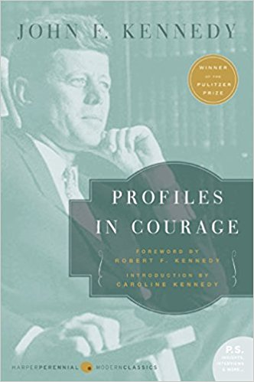

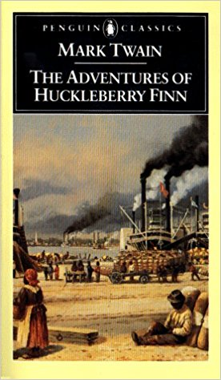

**Book 1**: The Adventures of Huckleberry Finn by Mark Twain (1884)

Synopsis: Commonly named among the Great American Novels, The Adventures of Huckleberry Finn was written in vernacular English and characterized by local color. Told in the first person point of view by its main character, "Huck", the novel delights the reader with compelling stories about the will of the human spirit and the quest for freedom and happiness while delving into controversial subjects that split an entire nation. With a masterful style, Twain invites us to experience a colorful description of people and places along the Mississippi River.

*Assignment 1*: Rhetorical Analysis

Define the following rhetorical strategies then find an example in the text and justify what effect it created. Be sure to use MLA format when citing the text, i.e. (Chpt, p#). Each response should be 3-5 sentences.

|  |  |  |  |
| --- | --- | --- | --- |
| Rhetorical Strategy | Definition | Example  (Chpt, p #) | Effect |
| Metaphor |  |  |  |
| Allusion |  |  |  |
| Antithesis |  |  |  |
| Tone |  |  |  |
| Personification |  |  |  |
| Imagery |  |  |  |
| Symbol |  |  |  |
| Anecdote |  |  |  |
| Vernacular |  |  |  |

*Assignment 2*: Analytical Essay

Write an organized essay of at least 1 ½ pages in response to the following question. You are to word process your response setting your paper up in MLA format, using 12 point Times New Roman font. Your paper is to be double-spaced and must use the novel to support your response.

In many works of literature, a physical journey (the literal movement from one place to another) plays a central role. In The Adventures of Huckleberry Finn, **how** is Huck and Jim’s river journey significant, AND **how** does it contribute to the meaning of the work as a whole? You should go beyond mere plot summary and reference specific parts of the text, incorporating well\chosen quotes and examples to help prove your thesis and reasons.

Possible things to consider include mood, tone, point of view, structure, selection of detail, diction (word choice), figurative language, theme, etc. Do your best on the writing assignment. It should be free of any errors and include all requirements.

**Book 2**: *Profiles in Courage* by John F. Kennedy

Synopsis: Written in 1955 by the then junior senator from the state of Massachusetts, John F. Kennedy's *Profiles in Courage* served as a clarion call to every American. The inspiring true accounts of eight unsung heroic acts by American patriots at different junctures in our nation's history, Kennedy's book became required reading, an instant classic, and was awarded the Pulitzer Prize. Now, a half-century later, it remains a moving, powerful, and relevant testament to the indomitable national spirit and an unparalleled celebration of that most noble of human virtues.

*Assignment 1*: Analytical Essay

After reading Chapter 1 of *Profiles in Courage*, define political courage. Then select two of the eight individuals Kennedy profiled and answer the following questions for each person selected:

1. How were this individual’s actions/decisions courageous?

2. What obstacles, dangers, or pressures did this individual encounter?

3. Do you believe this individual’s course of action best served the larger public interest? Why or why not?

4. In your opinion, does this individual exemplify political courage? Explain.

The analysis should be written in an essay format; introduction, body, and conclusion. Your name along with the course and date should be displayed at the top left side of your page with an original title. **Disclaimer** - even though you are being asked to only focus on two individuals you will need to be knowledgeable of all the men for an in-class synthesis essay.

**PLAGIARISM**

Plagiarism is a serious issue, and it will absolutely not be tolerated. Assignments must be completed individually, without collaboration with other people and/or outside reading sources (including the internet). Plagiarized work will earn a zero as well as disciplinary consequences.

WHAT IS PLAGIARISM?

Many people think of plagiarism as copying another's work or borrowing someone else's original ideas. But terms like "copying" and "borrowing" can disguise the seriousness of the offense. According to the Merriam-Webster Online Dictionary, to “plagiarize” means:

*to steal and pass off (the ideas or words of another) as one's own

*to use (another's production) without crediting the source

*to commit literary theft

*to present as new and original an idea or product derived from an existing source

**ALL OF THE FOLLOWING ARE CONSIDERED PLAGIARISM:**

-turning in someone else's work as your own

-copying words or ideas from someone else without giving credit

-failing to put a quotation in quotation marks

-giving incorrect information about the source of a quotation

-changing words but copying the sentence structure of a source without giving credit

-copying so many words or ideas from a source that it makes up the majority of your work, whether you give credit or not.

**Most cases of plagiarism can be avoided, however, by citing sources. Simply acknowledging that certain material has been borrowed and providing your audience with the information necessary to find that source is usually enough to prevent plagiarism.**

**SUBMISSION:** The assignment will be submitted electronically through Turnitin.com.

**CLASS ID: 17617478**

**ENROLLMENT PASSWORD: pioneer**

The work will be divided by books and submitted as such. **Final document** needs to be submitted online through www.turnitin.com **by 11:59 pm on Friday, September 7, 2018**. Please use the class ID and enrollment password above. If you have any questions as you work on your assignments, please e-mail [epalomin@sharylandisd.org](mailto:epalomin@sharylandisd.org).

Rubric for The Adventure for Huckleberry Finn

Assignment #1

|  |  |
| --- | --- |
| Requirements | Points |
| Student’s name, course, and date is displayed on the top left corner | ______/ 5 pts |
| Definitions - Students display accurate and effective denotations | _______/ 15 pts |
| Example - Student displays correct evidence that strongly supports the denotation as well as chapter and page number | _______/ 15 pts |
| Justification - Student demonstrates understanding of rhetorical strategies and their effect to the novel | _______/ 15 pts |
| TOTAL | _______/ 50 pts |

Assignment #2

|  |  |
| --- | --- |
| Requirements | points |
| Title - Student centers an original and unique title | ______/5 pts |
| Length - Student adheres to the minimum length of 1 ½ pages | ______5 pts |
| Organization - Student displays organized paragraphs; introduction, body, and conclusion | _____/10 pts |
| Understanding - Student displays strong understanding of prompt and shows evidence in their writing | _____/ 30pts |
| TOTAL | ______/ 50 pts |

Rubric for *Profiles in Courage*

Assignment #1

|  |  |
| --- | --- |
| Requirements | points |
| Student’s name, course, and date is displayed on the top left corner | ______/ 5pts |
| Introduction - Student displays the definition of political courage in a well-developed introduction and thesis. | ______/ 20 pts |
| Body - Student is able to respond to the questions in a well-developed paragraphs along with a good command of grammar and usage | _____/ 40 pts |
| Conclusion - Student is able to make a strong last statement and restate a thesis | _____/ 20 pts |
| Evidence - Student demonstrates accurate use of quotes; correctly cited | _____/ 15 pts |
| TOTAL | ______/ 100 pts |