Testing & Education Reference Center through MackinVia Portal

TERC: Provides access to ONLINE PRACTICE TESTS for AP, STAAR, ACT/SAT, Basic ENGLISH Skills, and lots more!
How to Access:
- MackinVia Tab
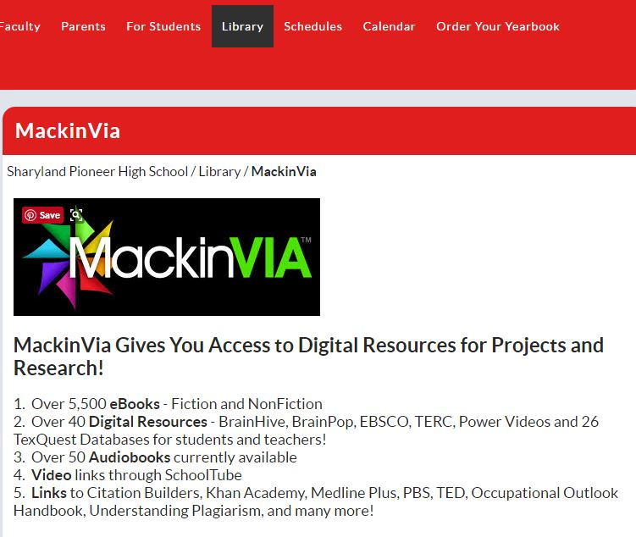
SELECT ICON
These Digital Resources are available to ALL PHS Students and Staff through the MackinVia Portal at www.mackinvia.com
- Select MackinVia icon
STUDENT SIGN IN: SCHOOL LOGIN CREDENTIALS
SCHOOL: Pioneer High School (Sharyland ISD)
USERNAME SAMPLE: AB012345
PASSWORD SAMPLE: AB678910

TEACHER SIGN IN:
SCHOOL: Pioneer High School (Sharyland ISD)
USERNAME: email prefix
PASSWORD: books

STAFF SIGN IN: Contact the library for the General Login Code

- MackinVia Sign In
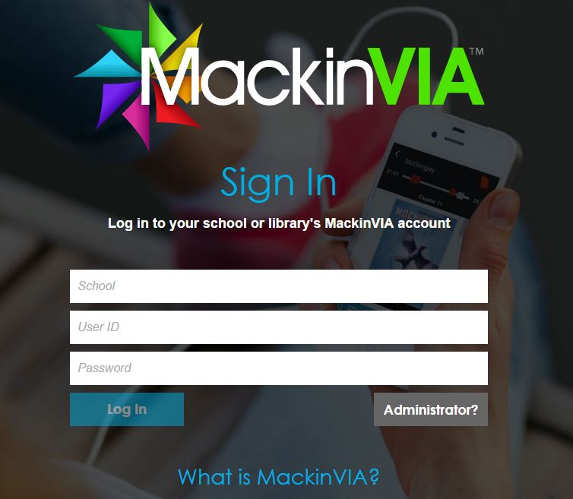
DOWNLOAD MackinVia ONTO YOUR MOBILE PHONE FOR EASY ACCESS!
- Select Digital Resources (TAB at left) and scroll down to GALE: Testing & Education Reference Center with Career Module and Open Now
Sharyland ISD Libraries subscribe to over 40 Different Databases through GALE and/or TexQuest. These are available 24/7 to all Students and Staff for Project or Research needs!
The eBooks are courtesy of PHS Library or Region One. There are almost 5,500 eBooks available on a wide variety of subject areas… Fiction and Nonfiction!
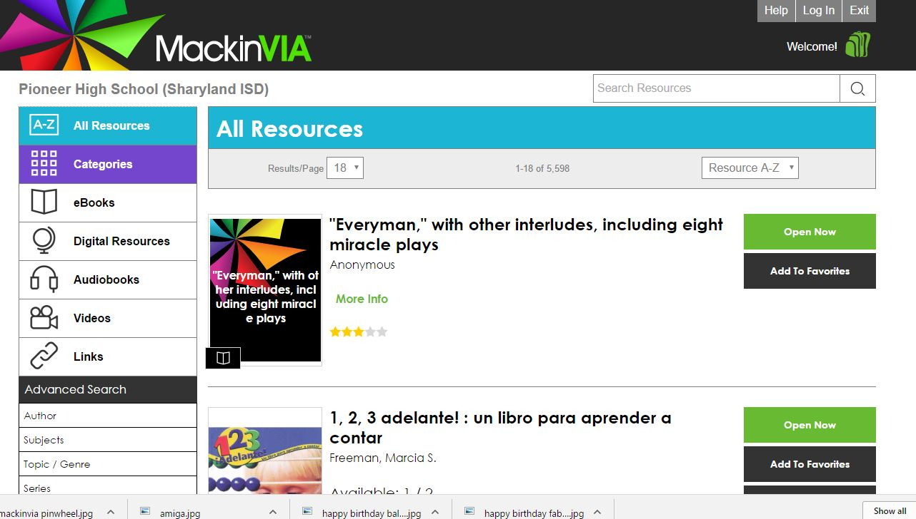
Databases
eBooks

- 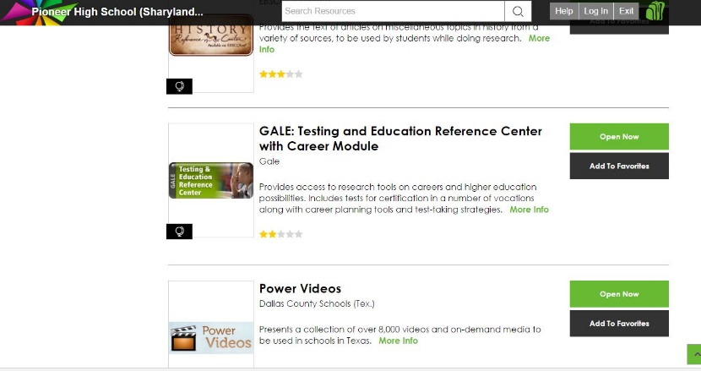
TERC Online Practice Exams

What type of student are you?
HIGH SCHOOL TOOLS: AP, HSE, STAAR, TAKS,
COLLEGE PREP TOOLS: ACT, PSAT, SAT, Scholarship Search, Resume, etc.
CAREER TOOLS: Career Assessment, Military, Virtual Career Library, etc.
GRAD SCHOOL TOOLS: GMAT, GRE, LSAT, MCAT, Grad School Search, etc.
INTERNATIONAL: Citizenship, TOEFL, TOEIC
- 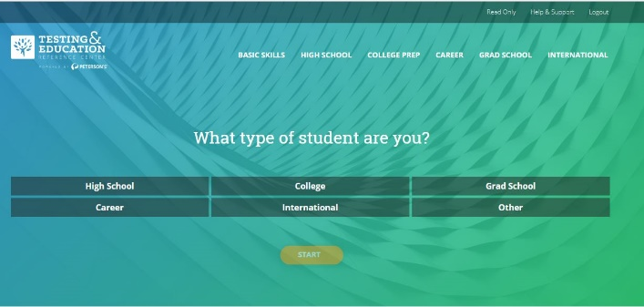

- STAAR Exams: Algebra, Biology, English I & II, US History
Yes, Staff and Faculty can practice online too!
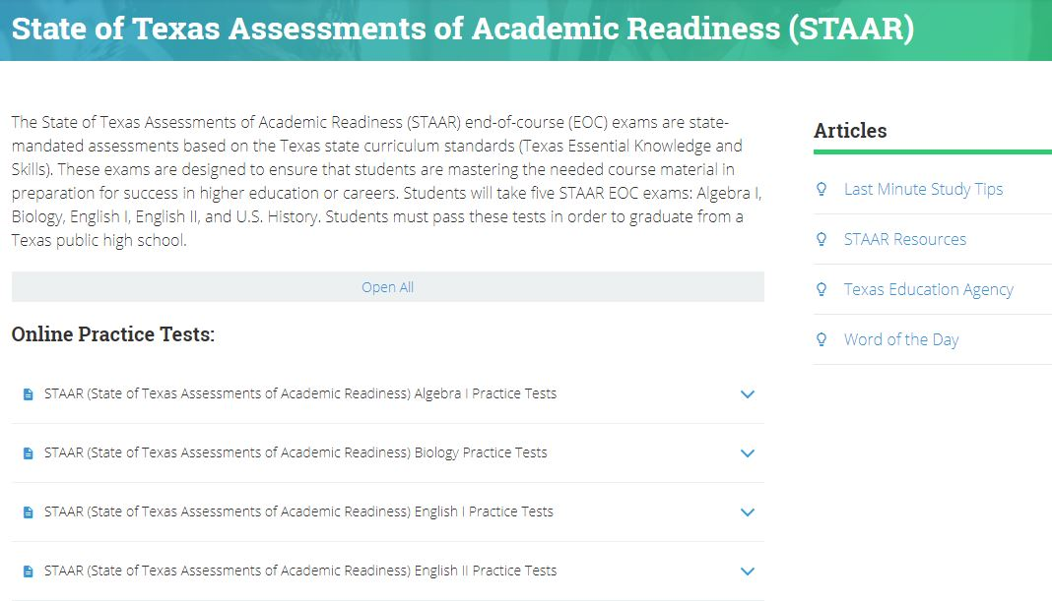
STAAR PREP states brief information about the exam and links the ONLINE PRACTICE TESTS and Related Links.
SELECT the Test you need.
SELECT the Start Now button.

- Log in or Register as a New User
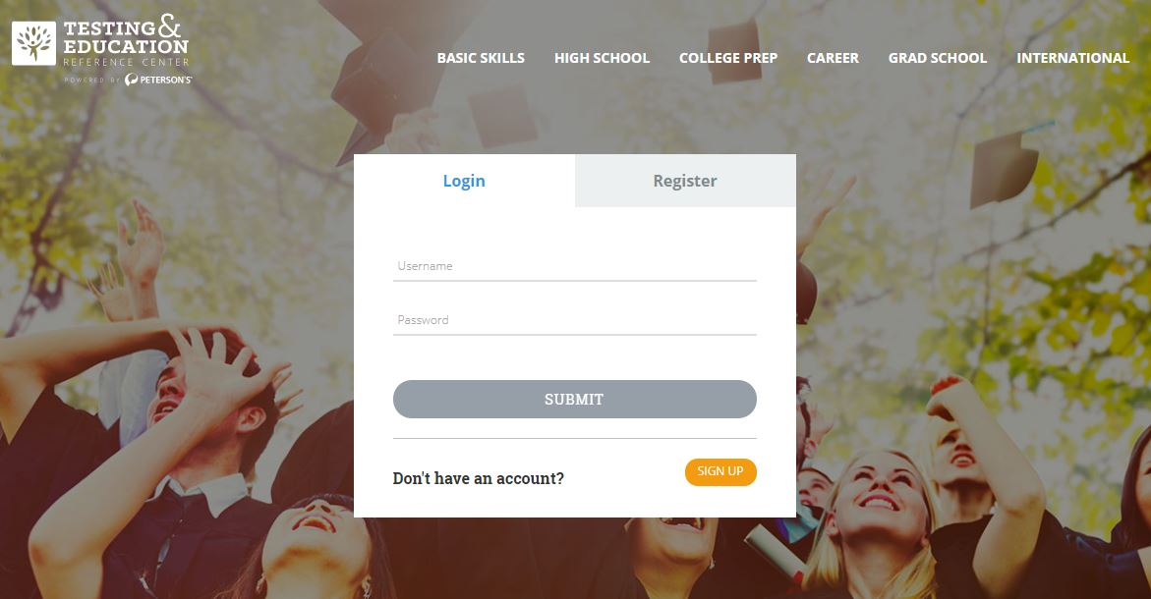
New Users will select the REGISTER NOW button to sign up for complete access.
Returning Users may log in to their account. They can also register as a New User if they wish to retake exams…especially for exams such as ACT, SAT & PSAT.

- Log in Recommendations
Students should include an email address to retrieve or reset the Username or Password.
Recommended Log in for New STUDENT Users: School Assigned Log in Credentials
Sample: U: AB012345 P: AB123456
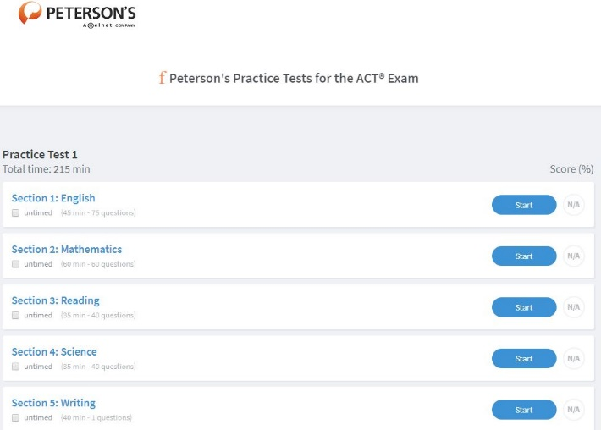
Select START to Improve Your Scores!

- Test Page
- 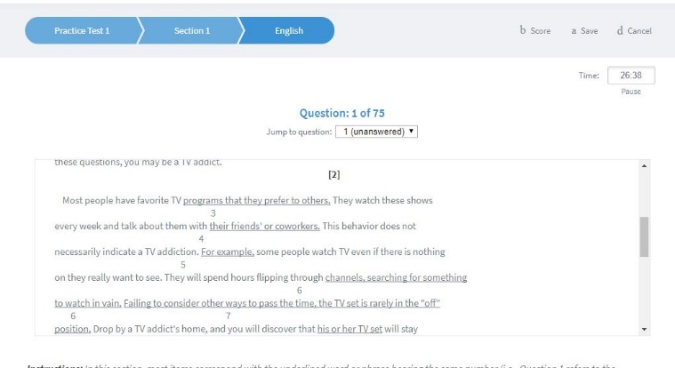
You are ready to START Testing!
DECIDE whether you will be taking the entire test or in Sections. Press START if you will be taking it at once.
CHECK UNTIMED: If you want to focus on questions at a slower pace OR have a shorter time period. Please SAVE before Exiting the TEST so that your answers are compiled.
SCORE %: The Test is scored at the completion of the Section or Test. It will give relevant information about your STRENGTHS AND WEAKNESSES. This can help you focus on your specific needs.

- Select Score, Save or Cancel
  - Score: If you completed or want to see how
You did
  - Save: If you want to return to an unfinished
Test
  - Cancel: To cancel out

- Military exams
  - Under Career TAB
  - ASVAB and AFOQT
  - Take a Pre-Test before your actual exam and improve your score!

- Check out the items under Career Tools:
- Basic Computer Skills
- Career/VoTech School Search
- Clerical
- Cosmetology, Firefighter, Medical/Nursing, Real Estate, Social Worker, Teacher, etc.
- Virtual Career Library
Brushing up on your English (reading/writing/grammar) skills? You’ve come to the right place! Dozens of interactive tutorials with quizzes to teach you important subject information.
Practice your English skills and

- Basic Skills English/Writing Tutorials
