Organ System Project

By

_________________

26

1

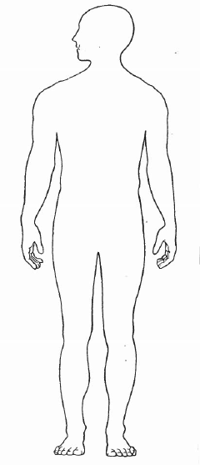

**Body System: __DIGESTIVE SYSTEM**

25

2

BODY SYSTEM: ___DIGESTIVE SYSTEM

Major Organs Involved:

Primary Function:

Interacting Systems:

BODY SYSTEM: _____REPRODUCTIVE SYSTEM

Major Organs Involved:

Primary Function:

Interacting Systems:



**Body System: ____CIRCULATORY SYSTEM**

3

24

BODY SYSTEM: ______CIRCULATORY SYSTEM

Major Organs Involved:

Primary Function:

Interacting Systems:



**Body System: ___REPRODUCTIVE SYSTEM**

23

4

BODY SYSTEM: ___LYMPHATIC SYSTEM_

Major Organs Involved:

Primary Function:

Interacting Systems:



**Body System: _____NERVOUS SYSTEM**

5

22



**Body System: ____LYMPHATIC SYSTEM**

21

BODY SYSTEM: ______NERVOUS SYSTEM

Major Organs Involved:

Primary Function:

Interacting Systems:

6



**Body System: ___EXCRETORY SYSTEM**

7

BODY SYSTEM: ______INTEGUMENTARY SYSTEM

Major Organs Involved:

Primary Function:

Interacting Systems:

20



**Body System: __INTEGUMENTARY SYSTEM**

19

BODY SYSTEM: _____EXCRETORY SYSTEM_

Major Organs Involved:

Primary Function:

Interacting Systems:

8



**Body System: __RESPIRATORY SYSTEM_**

9

BODY SYSTEM: _____IMMUNE SYSTEM_

Major Organs Involved:

Primary Function:

Interacting Systems:

18



**Body System: ___IMMUNE SYSTEM_**

17

BODY SYSTEM: _____RESPIRATORY SYSTEM_

Major Organs Involved:

Primary Function:

Interacting Systems:

10



**Body System: _SKELETAL SYSTEM____**

11

BODY SYSTEM: ___ENDOCRINE SYSTEM__

Major Organs Involved:

Primary Function:

Interacting Systems:

16



**Body System: ___ENDOCRINE SYSTEM_**

15



12

14

13

BODY SYSTEM: ______MUSCULAR SYSTEM___

Major Organs Involved:

Primary Function:

Interacting Systems:



**Body System: ___MUSCULAR SYSTEM_**