poetry contest
  - Don’t Miss Out on Your Chance to Win Prizes!
Theme:  “Healing & Hope”  Length:  1 Typed Page  Deadline:  March 21st @ 4:00 pm  jflores@sharylandisd.org | 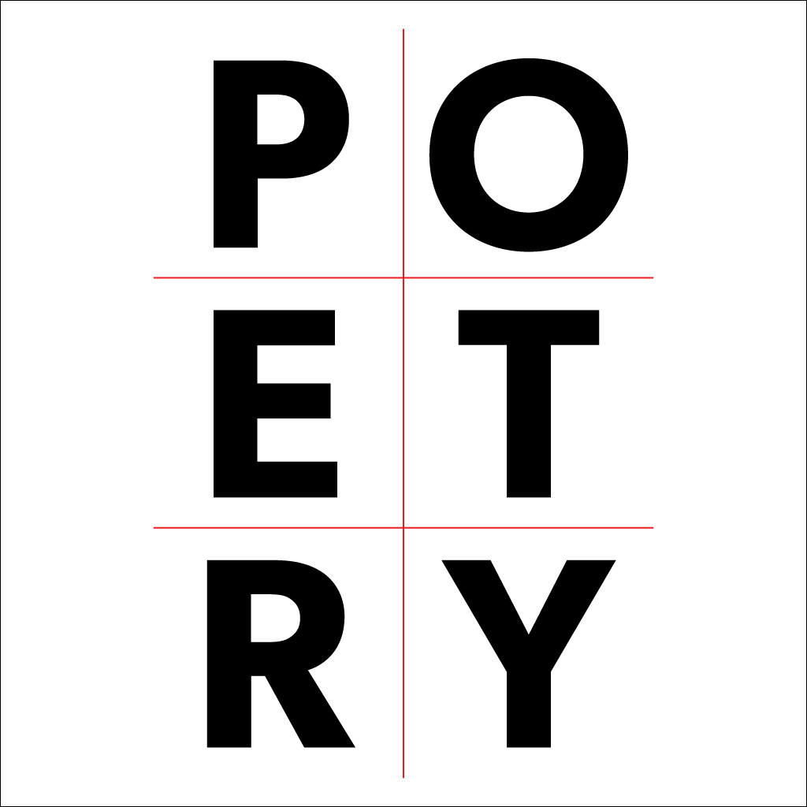

Frequently asked questions –
Yes, you may submit your “Healing & Hope” poem to both contests
Yes, you may submit 5 poems together through PDF for the Regional Contest

Pioneer High School Library

Contact your Librarian for additional information

