Sharyland ISD Summer Reading 2018-2019
English III- Pre-AP

Due Date: September 7, 2018

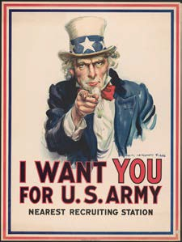
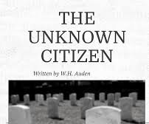
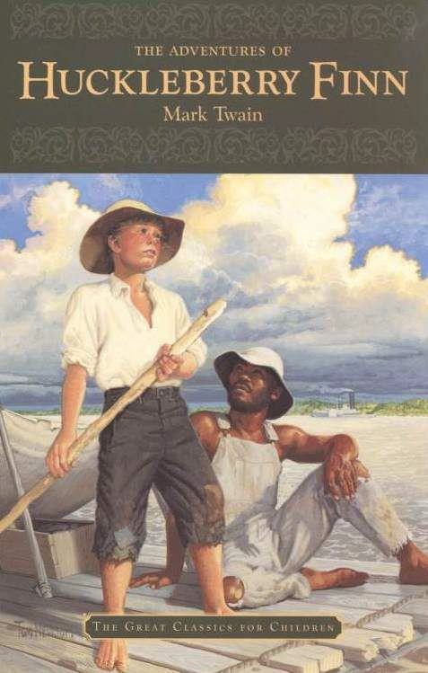
English III Honors students will read The Adventures of Huckleberry Finn by Mark Twain AND additional texts. Students will connect universal themes by utilizing a graphic organizer and answering short answer responses while completing an essay over the novel.

In The Adventures of Huckleberry Finn written by Mark Twain, a young runaway boards a raft and sets off down the Mississippi, setting in motion a series of memorable adventures. Huck Finn and his loyal companion, the escaped slave Jim, form one of literature's greatest friendships.

Assignment #1 - “Huckleberry Finn” by Mark Twain

“[Mark Twain] is surprisingly relevant right now. When you look at how much he wrote and the breadth of the subjects he wrote about, you know that if he were alive today, he would totally be a blogger.”
— Rebecca Fitting, an owner of the Greenlight Bookstore in Fort Greene, Brooklyn, quoted in the 2010 New York Times article “Mark Twain’s Autobiography Flying Off the Shelves.”

In ''Green Hills of Africa,'' after disposing of Emerson, Hawthorne and Thoreau, and paying off Henry James and Stephen Crane with a friendly nod, Ernest Hemingway proceeded to declare, ''All modern American literature comes from one book by Mark Twain called 'Huckleberry Finn.' .
. . It's the best book we've had. All American writing comes from that. There was nothing before. There has been nothing as good since.''
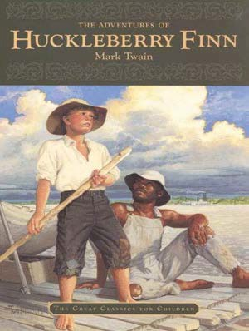

Directions: - Select one of the essay topics on the next page, and after reading and annotating The Adventures of Huckleberry Finn, write an essay in response to your chosen topic.
Specifics:
- 900 – 1100 word count; place your word count on the last page.
- MLA format (Times New Roman, 12 point, double space)
- Original title
- Parenthetical Citations and works cited page for Huckleberry Finn textual support; you should have no additional sources.
- Please do not use outside sources; this is your analysis, your interpretation. Use textual support from the novel not to pad, but complement & support your ideas.
- Place your word count at the end. (I know I said it before, but it bears repeating!)
- Be certain to have a clear, specific, original thesis statement – which should be the last sentence of your first paragraph.

Questions
- The story, set in the early 1800's, revolves around Huck and his developing friendship with a runaway slave, Jim, who is trying to escape to freedom in the North. While its critics say the book promotes a negative image of black people (Jim speaks in a crude dialect; the N- word is used over 200 times) – yet others contend that Huck serves as an example of emerging racial tolerance; he grows by the end of the story and sees Jim as a human being; Huck is overcoming the prejudiced values of his era. Discuss the development of the relationship between Huck and Jim. What is accomplished? Where do they stumble? Or fail? What must they overcome? What does their future hold? What choices are made by Mark Twain as he portrays their relationship?

- Much has been made about the use of the Mississippi River in this novel. It’s rather easy of course to call it “symbolic.” But what does it represent? Does the symbolism ebb and flow, shift and change like a current throughout the novel? Does it represent something different for different characters? What strategies are used by Mark Twain to make the most of his setting?

- American literary critic Lionel Trilling once claimed Jim is Huck’s true father. Agree? Disagree? Defend or refute this statement, while also commenting on the other potential “father” figures within this novel.

- From the outset of the novel, Huck and Tom are monetarily rich, although Huck is unable to use his money because of Pap. How are many of the characters and events shaped by economics? During the escape and adventure with Jim, Huck encounters people of every socio- economic level. How does he come to view wealth? How does Jim define wealth? How have money and the pursuit of wealth driven Huck’s story along the Mississippi?

Assignment #2 - SOAPSTone Graphic Organizer with Analysis

SOAPStone is an acronym for a series of questions to ask yourself when reading a piece of literature. It stands for Speaker, Occasion, Audience, Purpose, Subject, and Tone. It can help you understand the meanings behind works of literature, and even get you into the mind of the author. Your job is to offer an in depth analysis over the 3 provided selections and answer the following questions. The following Graphic Organizer is available for you to use. If you choose to create your own, be sure to include all the elements required.

Articles Provided to the student:

  - Poem - The Unknown Citizen by W.H. Auden
  - Excerpt - from The Narrative of the Life of Frederick Douglass
  - Advertisement - I Want You

Directions:

You will read the texts provided and make any annotations that you observe; diction, appeals, speaker, themes, etc.
- You will create a SOAPSTone for EACH text. (A template with expectations has been provided for you.)
- Then you will write short answer responses (250-300 words) for all the questionslistedbelow.Usethefollowing using information you recorded in your SOAPSTone graphic organizers you completed.
  - What is the purpose of the text and how does the interaction among speaker, audience, and subject affect the text?
  - How does the text appeal to Ethos, Pathos, and Logos?
  - How effective is the text in achieving its purpose?

PLAGIARISM
Plagiarism is a serious issue, and it will absolutely not be tolerated. Assignments must be completed individually, without collaboration with other people and/or outside reading sources (including the internet). Plagiarized work will earn a zero as well as disciplinary consequences.
WHAT IS PLAGIARISM?
Many people think of plagiarism as copying another's work or borrowing someone else's original ideas. But terms like "copying" and "borrowing" can disguise the seriousness of the offense. According to the Merriam-Webster Online Dictionary, to “plagiarize” means:
*to steal and pass off (the ideas or words of another) as one's own
*to use (another's production) without crediting the source
*to commit literary theft
*to present as new and original an idea or product derived from an existing source

ALL OF THE FOLLOWING ARE CONSIDERED PLAGIARISM:
-turning in someone else's work as your own
-copying words or ideas from someone else without giving credit
-failing to put a quotation in quotation marks
-giving incorrect information about the source of a quotation
-changing words but copying the sentence structure of a source without giving credit
-copying so many words or ideas from a source that it makes up the majority of your work, whether you give credit or not.
Most cases of plagiarism can be avoided, however, by citing sources. Simply acknowledging that certain material has been borrowed and providing your audience with the information necessary to find that source is usually enough to prevent plagiarism.
SUBMISSION: The assignment will be submitted electronically through Turnitin.com.
CLASS ID: 18058925
ENROLLMENT PASSWORD: PioneerSRA
The work will be divided by books and submitted as such. Final document needs to be submitted online through www.turnitin.com by 11:59 pm on Friday, September 7, 2018. Please use the class ID and enrollment password above. If you have any questions as you work on your assignments, please e-mail: bolvera@sharylandisd.org

THE UNKNOWN CITIZEN BY W. H. AUDEN

(To JS/07 M 378
This Marble Monument Is Erected by the State)

He was found by the Bureau of Statistics to be One against whom there was no official complaint, And all the reports on his conduct agree
That, in the modern sense of an old-fashioned word, he was a saint, For in everything he did he served the Greater Community.
Except for the War till the day he retired He worked in a factory and never got fired,
But satisfied his employers, Fudge Motors Inc. Yet he wasn't a scab or odd in his views,
For his Union reports that he paid his dues, (Our report on his Union shows it was sound) And our Social Psychology workers found
That he was popular with his mates and liked a drink. The Press are convinced that he bought a paper everyday
And that his reactions to advertisements were normal in every way. Policies taken out in his name prove that he was fully insured,
And his Health-card shows he was once in a hospital but left it cured. Both Producers Research and High-Grade Living declare
He was fully sensible to the advantages of the Installment Plan And had everything necessary to the Modern Man,
A phonograph, a radio, a car and a frigidaire. Our researchers into Public Opinion are content
That he held the proper opinions for the time of year;
When there was peace, he was for peace: when there was war, he went. He was married and added five children to the population,
Which our Eugenist says was the right number for a parent of his generation. And our teachers report that he never interfered with their education.
Was he free? Was he happy? The question is absurd:
Had anything been wrong, we should certainly have heard.

From Another Time by W. H. Auden.

Excerpt from Narrative Of The Life of Frederick Douglass

Frederick Douglass

Very soon after I went to live with Mr. and Mrs. Auld, she very kindly commenced to teach me the A, B, C. After I had learned this, she assisted me in learning to spell words of three or four letters. Just at this point of my progress, Mr. Auld found out what was going on, and at once forbade Mrs. Auld to instruct me further, telling her, among other things, that it was unlawful, as well as unsafe, to teach a slave to read.

I was now about twelve years old, and the thought of being a slave for life began to bear heavily upon my heart. Just about this time, I got hold of a book entitles "The Columbian Orator." Every opportunity I got, I used to read this book. Among muchof other interesting matter, I found in it a dialogue between a master and his slave. The slave was represented as having run away from his master three times. The dialogue represented the conversation which took place between them, when the slave was retaken the third time. In this dialogue, the whole argument in behalf of slavery was brought forward by the master, all of which was disposed of by the slave. The slave was made to say some very smart as well as impressive things in reply to his master- things which had the desired though unexpected effect; for the conversation resulted in the voluntary emancipation of the slave on the part of the master.

In the same book, I met with one of Sheridan's mighty speeches on and in behalf of Catholic emancipation. These were choice documents to me. I read them over and over again with unabated interest. They gave tongue to interesting thoughts of my own soul, which had frequently flashed through my mind, and died away for want of utterance. the moral which I gained from the dialogue was the power of truth over the conscience of ever a slave holder. What I got from Sheridan was a bold denunciation of slavery, and a powerful vindication of human rights. The reading of these documents enabled me to utter my thoughts, and to meet the arguments brought forward to sustain slavery; but while they relieved me of one difficulty, they brought on another even more painful than the one of which I was relieved. The more I read, the more I was led to abhor and detest my enslavers. I could regard them in no other light than a band of successful robbers, who had left their homes, and in a strange land

reduced us to slavery. I loathed them as being the meanest as well as the most wicked of men. As I read and contemplated the subject, behold! That very discontentment which Master Hugh had predicted would follow my learning to read had already come, to torment and sting my soul to unutterable anguish.

NEAREST RECRUITING STATION

r; I r, u; Ut•.J .;t Ot . M Y.

World War I produced one of the most memorable images in American history: the U.S. Army recruiting poster that depicts a commanding Uncle Sam pointing his finger at the viewer and urging young men to enlist in the war effort. Painted by noted U.S. illustrator James Montgomery Flagg, the image first appeared on the cover of the July 6, 1916, issue of Leslie’s Weekly magazine with the title “What Are You Doing for Preparedness?” The U.S. would not declare war on Germany until April of the next year, but the storm signals were clear. The image was later adapted by the U.S. Army for the poster with the new, unforgettable call to action. More than 4 million copies of it were printed between 1917 and 1918.

SOAPStone Analysis Name:

 | Description & Expectation | The Unknown Citizen | Frederick Douglass Excerpt | I Want You Poster
S | What is the SUBJECT of the piece? What are the general topics, content, and/or ideas contained in the text. How do you know this from the text? Summarize the text.
O | What is the OCCASION?  What are the time and place? What prompted the author to write the piece? What event led to the development? How do you know this from the text?
A | Who is the AUDIENCE?  To whom is the piece directed? What assumptions can you make about the audience? Are there any words or phrases that are unusual or different? Why is the speaker using this type of language? How do you know this from the text?

SOAPStone Analysis Name:

P | What is the PURPOSE?  What is the reason for the text? Why was it written? What goal did the author have in mind? How do you know this from the text?
S | Who is the SPEAKER?  Who is the voice that is speaking? What do we know about this person? What is his/her background? Is there a bias in what is written? How do you know this from the text?
Tone | What is the TONE of the piece? What is the attitude expressed by the speaker? How do you know this? Examine the words and imagery to show where in the text your answer is supported.

Part A - Essay

Requirements | Points
Heading - Student’s name, course, and date is displayed on the top left corner | / 5 pts
Introduction / Thesis - Engaging opening introduces the essay’s general topic and inspires thinking about that topic; thesis is an easily identifiable. | / 10 pts
Body Paragraphs / Organization - Each topic sentence clearly connects to the thesis and offers an identifiable, well-phrased idea to be proven in the paragraph; concrete details are well-chosen and incorporated. | / 15 pts
Literary Analysis - Writing reflects a critical, analytical understanding of the text; through clear reasoning, writer draws sophisticated, insightful inferences from concrete details to support the connected ideas of the thesis. | / 15 pts
Language Style / Voice - Writing is academic in tone, demonstrating a clear sense of purpose and audience; writer's voice is evident -- confident and sophisticated. | / 15 pts
Mechanics - Effective syntax and grammar demonstrate a mastery of writing conventions and serve the author’s purpose. | / 10 pts
Total | / 70 pts

Part B - SoapsTONE Analysis

- The Unknown Citizen Poem
- “History Is a Weapon” Narrative of the Life of Frederick Douglas Excerpt

“I Want You” Poster

5 – Analysis is very clear and detailed in  ALL categories and easy to read.  4 – Analysis is very clear and detailed in  MOST categories and easy to read.  3 – Analysis is very clear and detailed in  SOME categories and easy to read.  1 – Analysis is rarely evident or not clear and difficult to see or read.  0 – NO analysis is readily seen. | 5 – Evidence is present and ACCURATE and specifically drawn from the document and easy to read.  4 – Evidence is present, and MOSTLY ACCURATE and specifically drawn  from  the document and easy to read.  3 – Evidence is limited, SOMEWHAT ACCURATE and is vague.  1 – Evidence is minimal RARELY and is vague.  0 – NO evidence is given or apparent to support the analysis.
The Unknown Citizen Poem | / 10 pts
“History is a Weapon” Excerpt | / 10 pts
“I Want You” Poster | / 10 pts
Total | / 30 pts

Part A – Essay | / 70 pts
Part B - SOAPSTONE Analysis | / 30 pts
Total | / 100 pts

